Practical(1.1.1)
Aim Write a Python program that calculates the area of a circle when the radius is provided by the user. Use π = 3.14 and display the area.

Algorithm:
Step 1: Start
Step 2: Input radius
Step 3: Area = 3.14 * r *r
Step 4: Output area up to 4 decimal places
Step 5: Stop
Stop
Output area upto
4 decimal places
Area = 3.14 * r* r
Input radius r
rr
FLOWCHART
start

EXECUTION
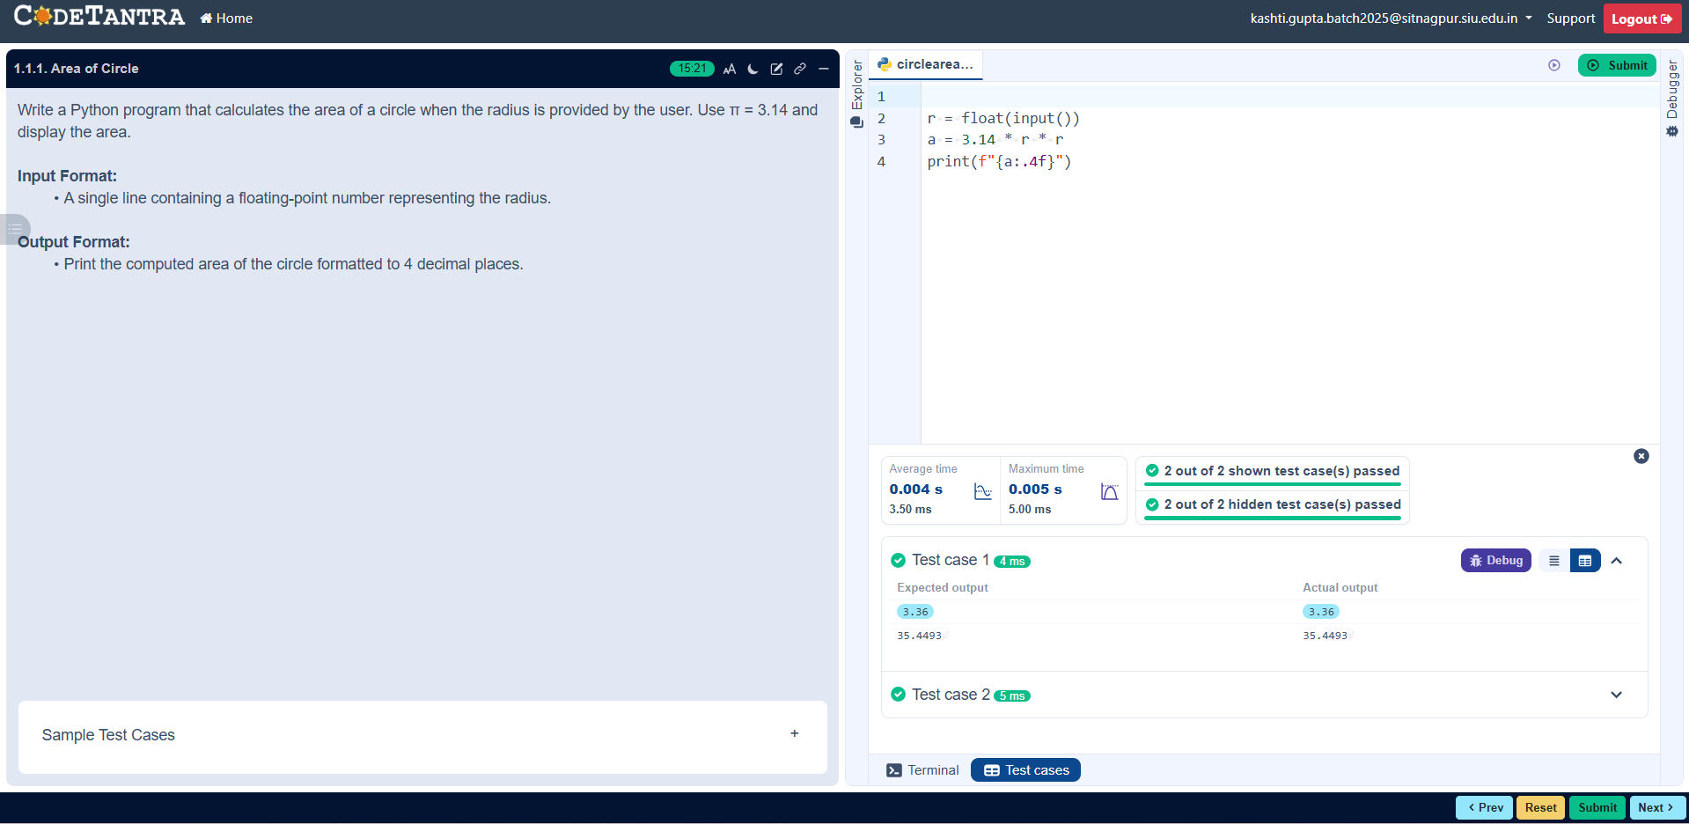

Practical(1.1.2)
AIM: Write a Python program to calculate the area of a rectangle given its length and width.

ALORITHM:
Step 1: Start
Step 2: Input Length and Width
Step 3: Area = Length * Width
Step 4: Output area up to 2 decimal places
Step 5: Stop
FLOWCHART
start
Input Length and Width
rr
Area = Length * Width
Output area upto
2 decimal places
Stop

EXECUTION
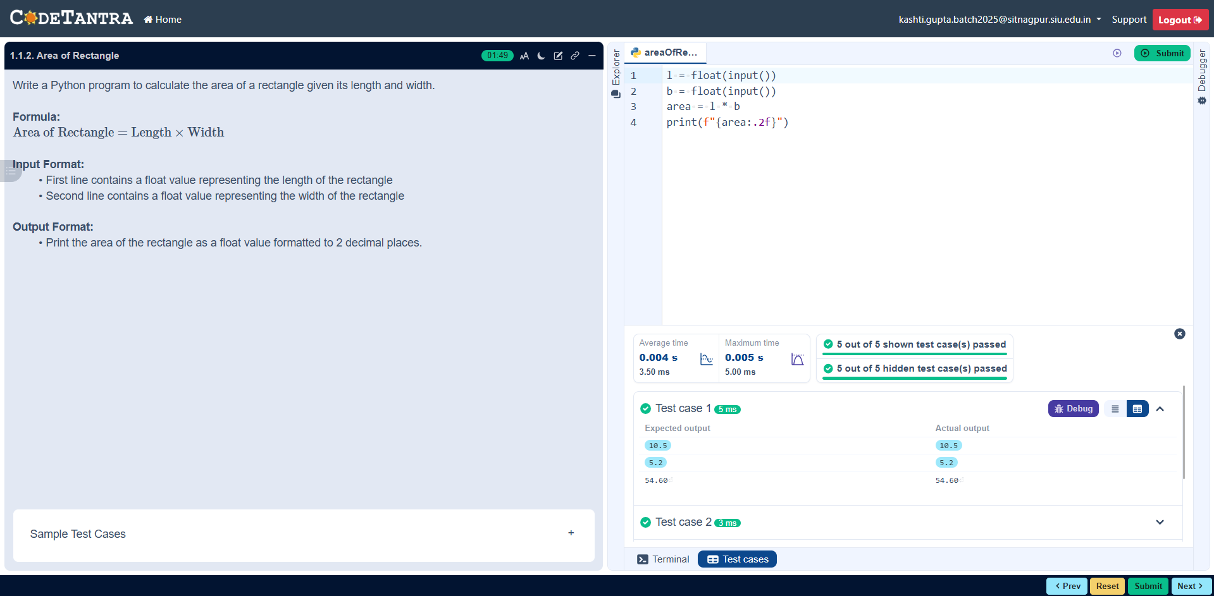

Practical 1.1.3
Aim: Write a Python program that prompts the user to enter the side_length of a square and computes the area of the square..
Algorithm
Step 1: Start
Step 2: Input side_length
Step 3: Area = side_length * side_length
Step 4: Output area
Step 5: Stop
FLOWCHART
start

Input side_length

Area = side_length
Side_length

Output area

Stop

EXECUTION


Practical (1.1.4)
Aim: Write a Python program that prompts the user to enter the triangle's base and height and computes the triangle's area.
Algorithm
Step 1: Start
Step 2: Input base and height
Step 3: Area = 0.5 * base * height
Step 4: Output area
Step 5: Stop
FLOWCHART
start

Input base and height

Area = 0.5 * base *
height

Output area

stop
Stop

EXECUTION
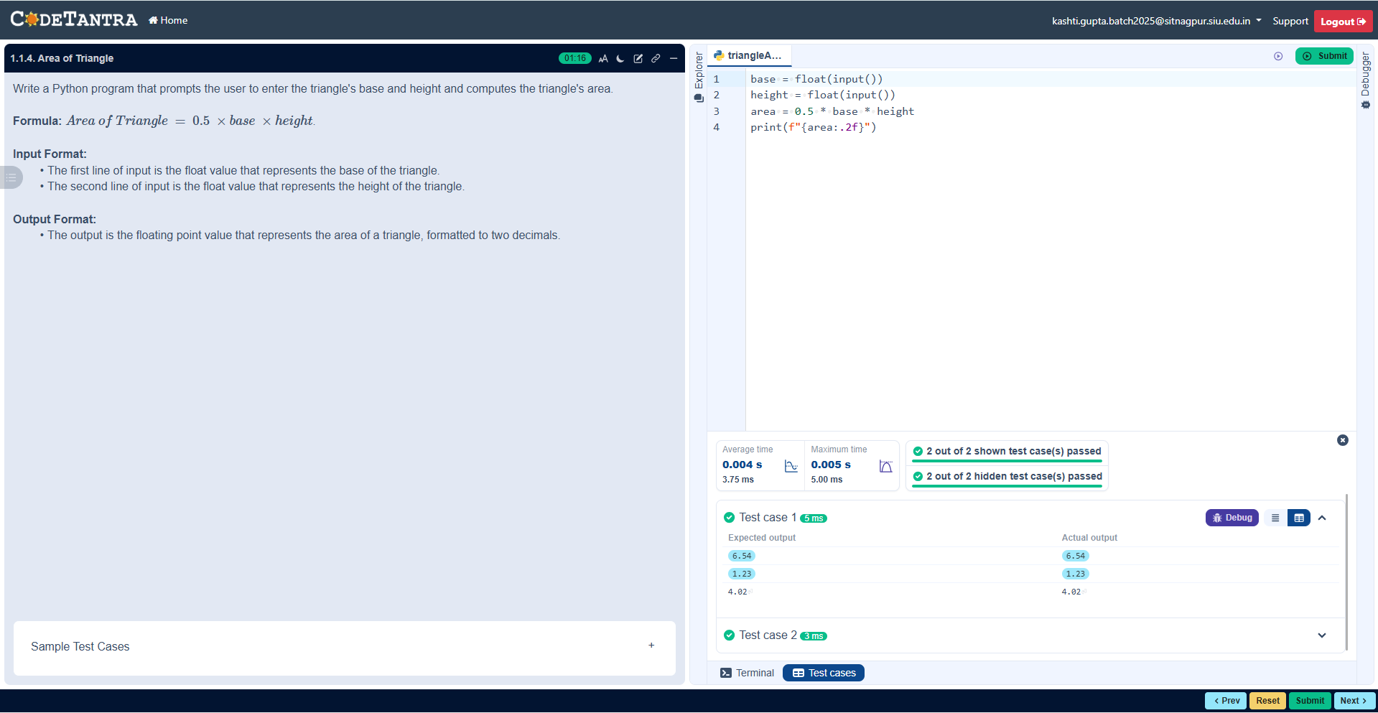
Practical 1.1.5
Aim: Write a Python program to determine whether a student passed the exam or not based on their marks.

ALGORITHM:
Step 1: Start
Step 2: Input marks
Step 3: Is marks >= 40
Step 4: If >= 40
Print “Pass”
Step 5: Else
Print “Fail”
Step 6: Stop
FLOWCHART
Is marks >= 40

start

Input marks

Yes No
Is marks > = 40
Print Pass
Pass
Print Fail

Stop

EXECUTION
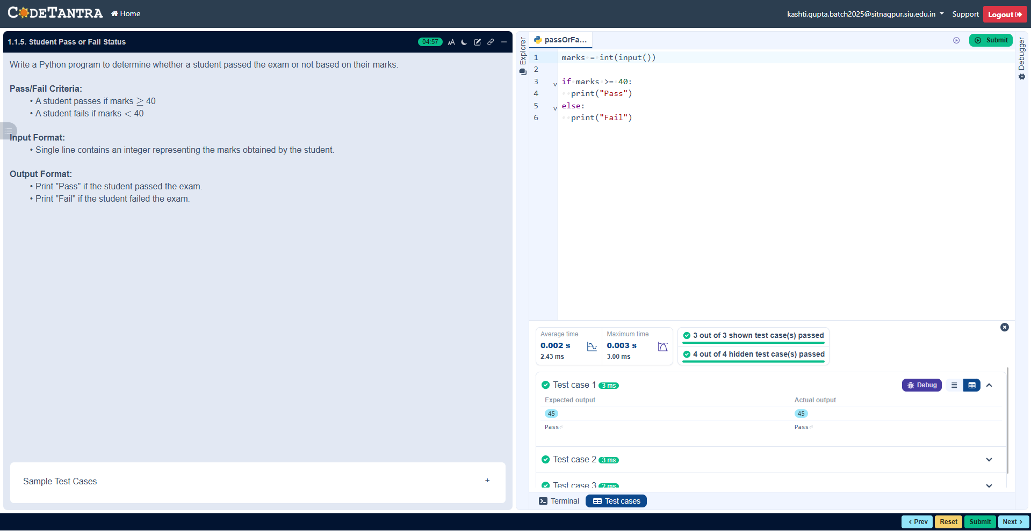

2.1.1. Roots of a Quadratic Equation
Aim: Write a program to find the roots of a quadratic equation, given its coefficients a, b, and c . Use the quadratic formula:
ALGORITHM
Step 1 : Start.
Step 2 : Read the coefficients a, b, and c.
Step 3 : Calculate the discriminant using:- d = b^2−4ac.

Step 4 : If D > 0 Compute:- 1=(− +root )/2a and 2=(− −root )/2 Display two real Step 5 : Else if D = 0 Compute:- 𝑥=−𝑏/2𝑎 Display equal real roots. 𝑏 𝑎 𝐷 and distinct roots.
Step 6 : Else (D < 0) Compute:- Real part = − /2 Imaginary part = root(- )/2a Step 1 :
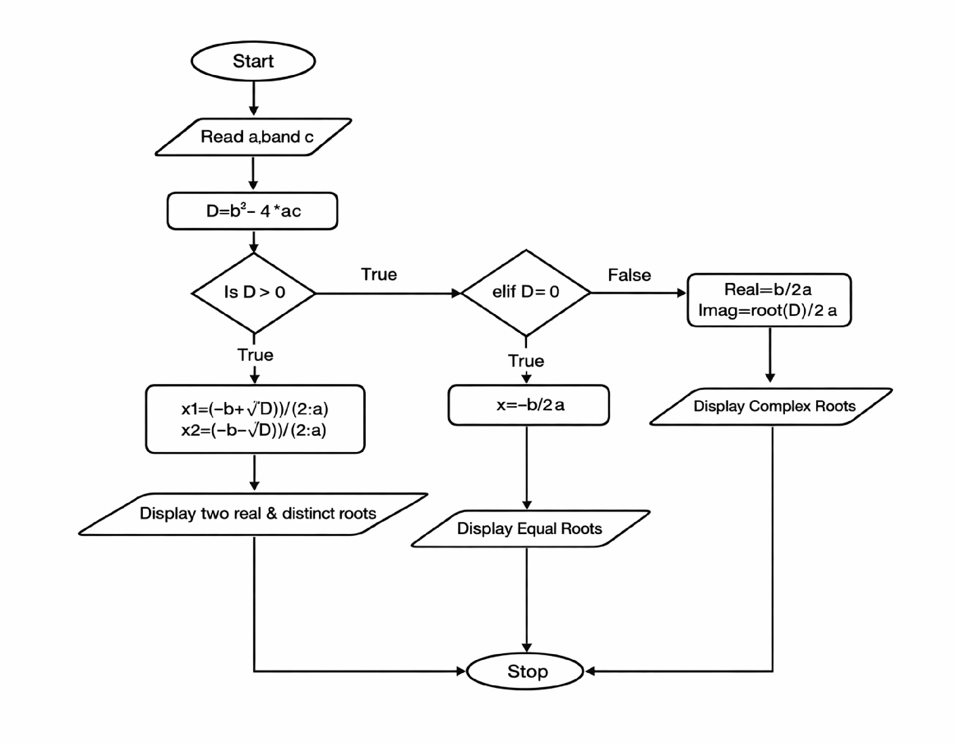
Display complex roots. Step 7 : Stop.

EXECUTION
